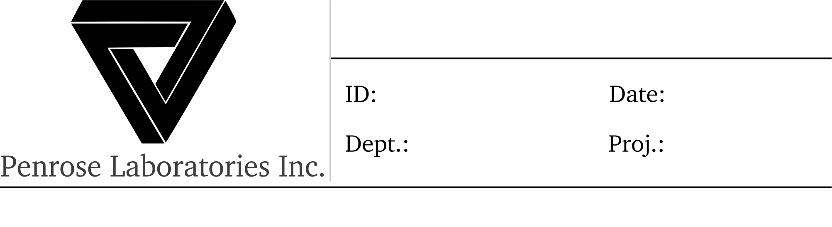
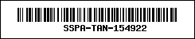
EV : “Echo Victor 396 to Sierra Delta 277, continue pursuit. over.”
SSPA
8/27/1993
Tango
Specimen no. 59294142 acquisition plan
Echo Victor 396
SD : “Sierra Delta, Continue pursuit, copy.”
<---> add note
NF : “November Foxtrot 538 to Echo Victor 396, Target location reached, Request update on tango. Over.”
EV : “Echo Victor 396, Maintain position, keep team on standby. No visuals on Tango yet. Over.”
NF : “November Foxtrot 538, Maintain position, team standby, copy.”
<---> add note
“Echo Victor 396 to Sierra Delta 277, requesting update on Tango, over.”
<..> open radar
SD : “Sierra Delta 277, track confidence high, SNR is high, will probably get visuals on Tango soon, over.”
<---> add note
SD : “Echo Victor, do you copy?” EV : ‘ehh“Echo victor, copy.”
<--->
SD : “Sierra Delta 277 to Echo Victor 396, Got visuals on Tango, I repeat, visuals. on. Tango. Over.”
EV : “Echo Victor 396, visuals on tango, copy. Report back in when locked on, over.”
<---> add note
EV : “Echo Victor 396 to November Foxtrot 538, Advance to sector Golf-six, Sierra Delta got visuals on Tango. Keep your team on high alert, capture may be imminent. Over.”
NF : “November Foxtrot 538, Sector Golf-six, Visuals on tango, High alert, copy.”
<---> open and close radar.
SD : “Sierra Delta 277 to Echo Victor 396, Locked on to Tango, Uplink established, Request for strike inbound. over”
EV : “Echo Victor 396, Tango Lock, Uplink, Strike request inbound, copy.”
<---> add note | Master switch to open auth window
EV : “Echo Victor 396 to Sierra Delta 277, Strike authorised, good luck. over.”
SD : “Sierra Delta 277, Strike Authorised, copy.”
<--->
SD : “SIERRA DELTA 277 TO ECHO VICTOR 396 TANGO DOWN, I REPEAT TANGO DOWN. OVER.”
EV : “Echo, Copy”
EV : “Echo victor 396 to November Foxtrot 538, tango down, tango down, move up now, over.”
NF : “November Foxtrot 538, Move up, copy”.
<---> add note
NF : “November Foxtrot 538 to Echo Victor 396, Tango captured, Unconscious, Vitals nominal, over.”
EV : “Echo Victor 396, Tango captured, Unconscious, Vitals normal, copy. Commence near field neural disruption. Great work guys!”
add note

